Search Labor Rate Search Guide

The e-GOS labor rate search tool enables agencies to search and view contractor labor rates for all 137 labor categories. To begin a search, follow these simple steps:

  - Select “Search Labor Rates” at the main e-GOS Dashboard.
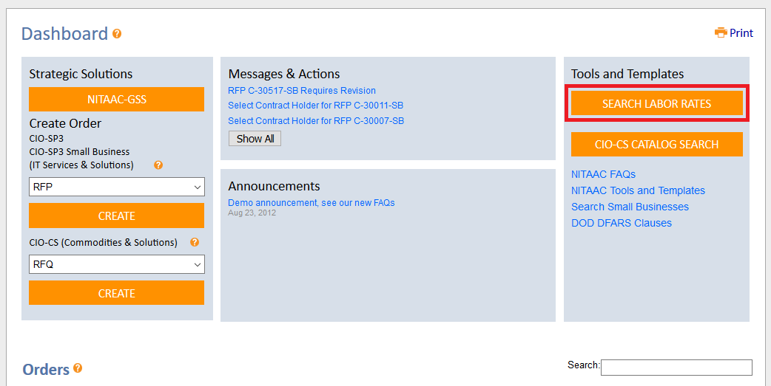
  - Select either CIO-SP3 or CIO-SP3 Small Business.
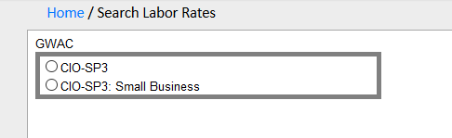

  - Select the labor categories, work location and contractors. If CIO-SP3 Small Business was selected choose a set-aside category. Click the “Search” button.
Note: NITAAC recommends using average rates for the selected contractors.
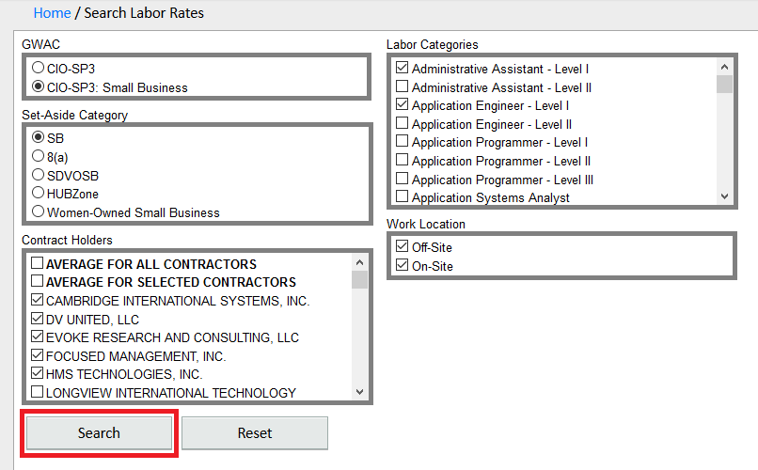

  - Open the Microsoft Excel notification by selecting “OK”.
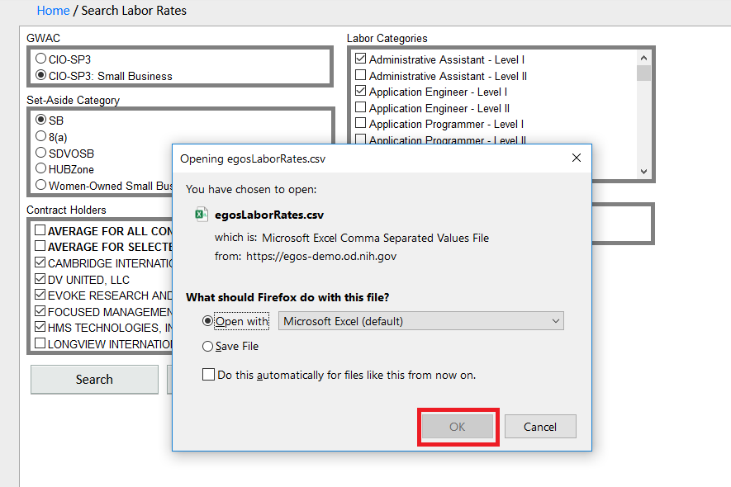

  - The labor rates are downloaded to an Excel spreadsheet as shown below.
